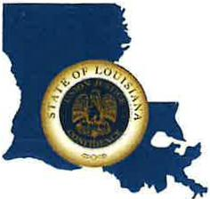 | CAPITAL AREA GROUNDWATER CONSERVATION DISTRICT
GARY I. BEARD
EXECUTIVE DIRECTOR

MEETING NOTICE
Capital Area Groundwater Conservation District Administrative Committee Meeting

WHEN: February 16, 2023

TIME: 10:30 a.m.

WHERE: Renaissance Baton Rouge
7000 Bluebonnet Blvd.
Baton Rouge, LA 70810

Contact Person: Lisa Manda, (225) 293-7370

